
October 13, 2024
MADE BY: Stephen Li
ID: 19488679
Wintec
EMAIL VERIFICATION ENDPOINT TEST REPORT

Email Verification Endpoint Specification

Email verification after registration.
Accepted user type: student client

Request
Method | URL
POST | api/emailVerification/

Type | Params | Values
POST | server_ref | string
POST | otp | string

Response
Status | Response
200 | {“description“:”Email verification successful. Please Sign In”}
400 | {"error":"server_ref or OTP is empty"}
401 | {"error":"Invalid server_ref. Please try again"}
401 | {"error":"Invalid OTP. Please try again"}
410 | {"error":"Invalid OTP. OTP has expired"}
500 | {"error":"Something went wrong. Please try again later"}

Process Flow
- Check user_verification table for matching active server_ref & OTP
  - [server_ref={server_ref} && otp={otp} and status=1]
- If record found →
  - Update status to 0 in user_verification table
  - Update user_status =1 in application_users
  - Add a record to the students table with student_email and submission_date
  - Return success response
- If record not found →
  - Update status to 0 in user_verification table [where server_ref={server_ref}]
  - Return 401 error code with response

All Bugs Identified in Postman

Bug 1: Test Incorrect OTP Code
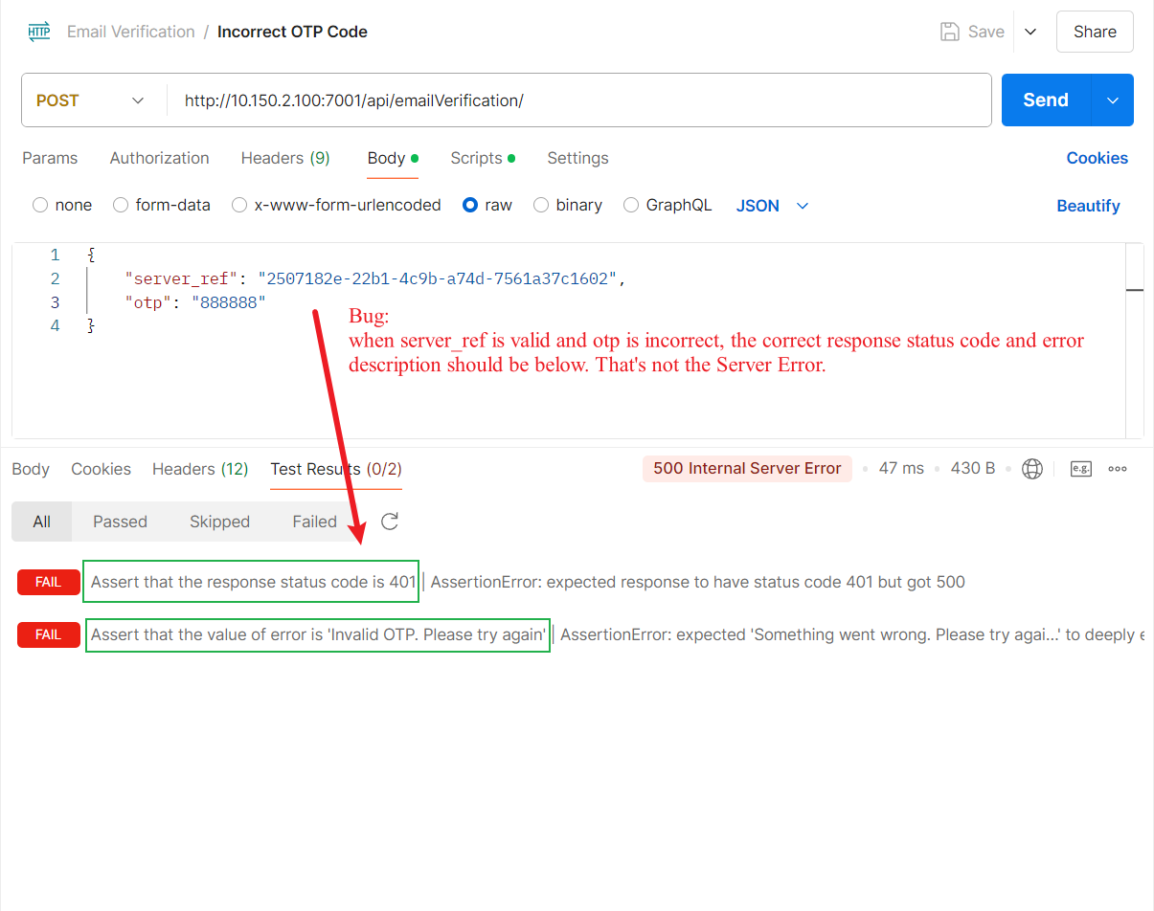

Bug 2: Test OTP Code is empty
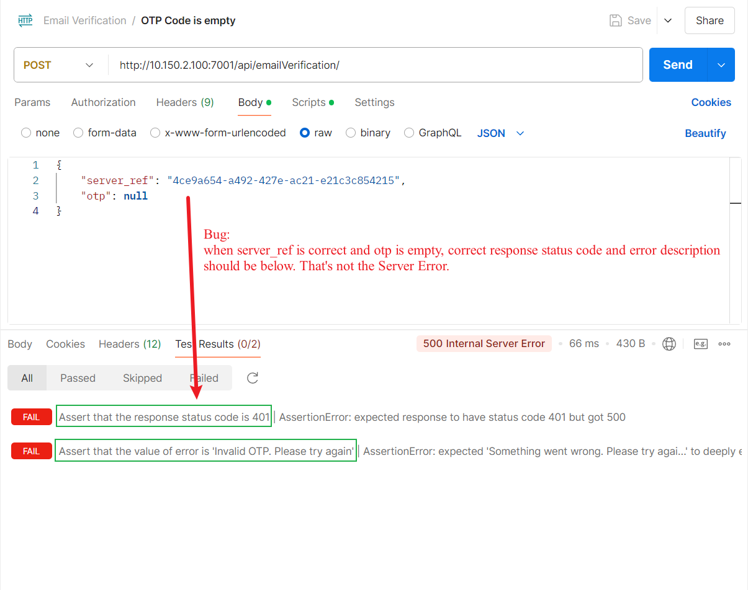

Bug 3: Test server_ref is empty
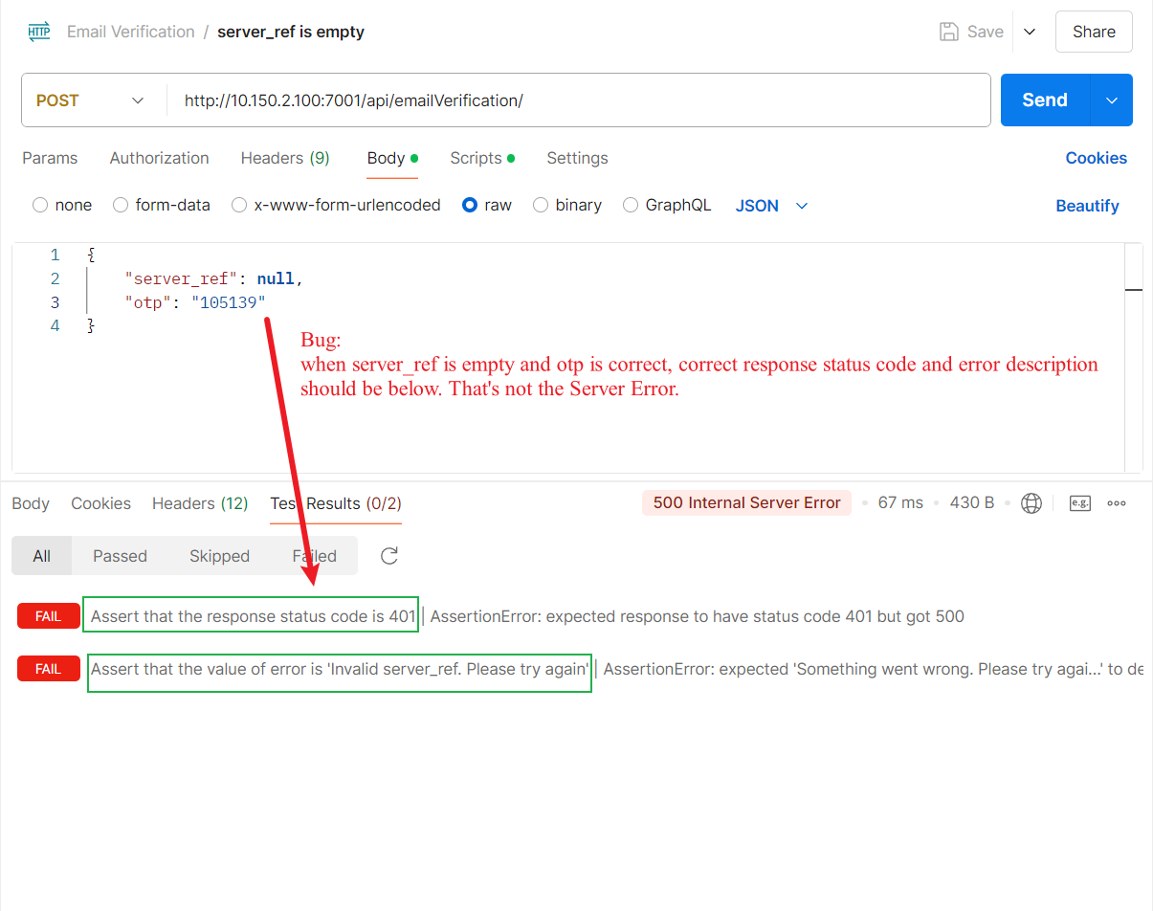

Bug 4: Test 6 digit OTP Code contains letters
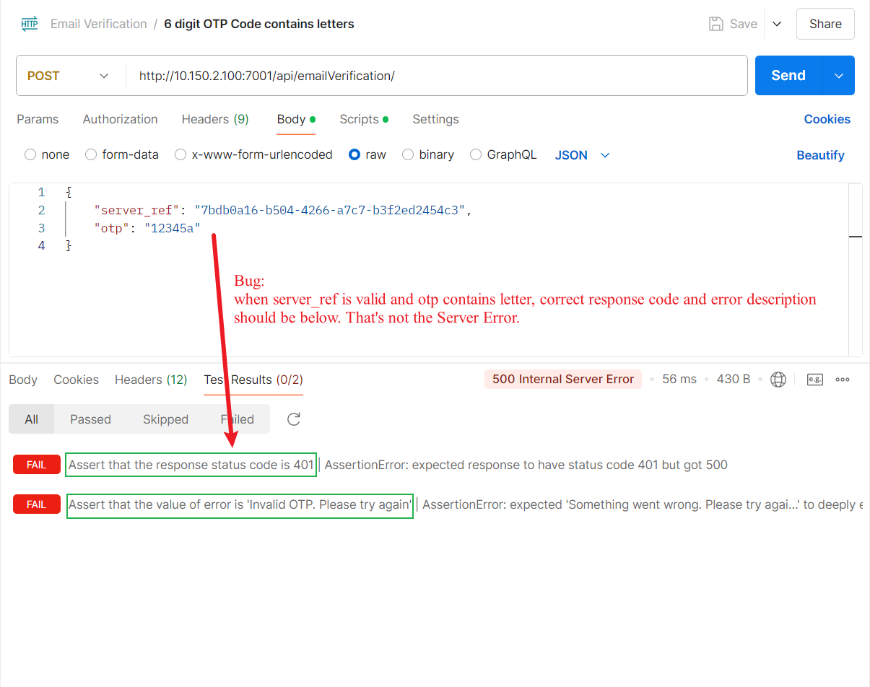

Bug 5: Test 6 digit OTP Code contains special characters
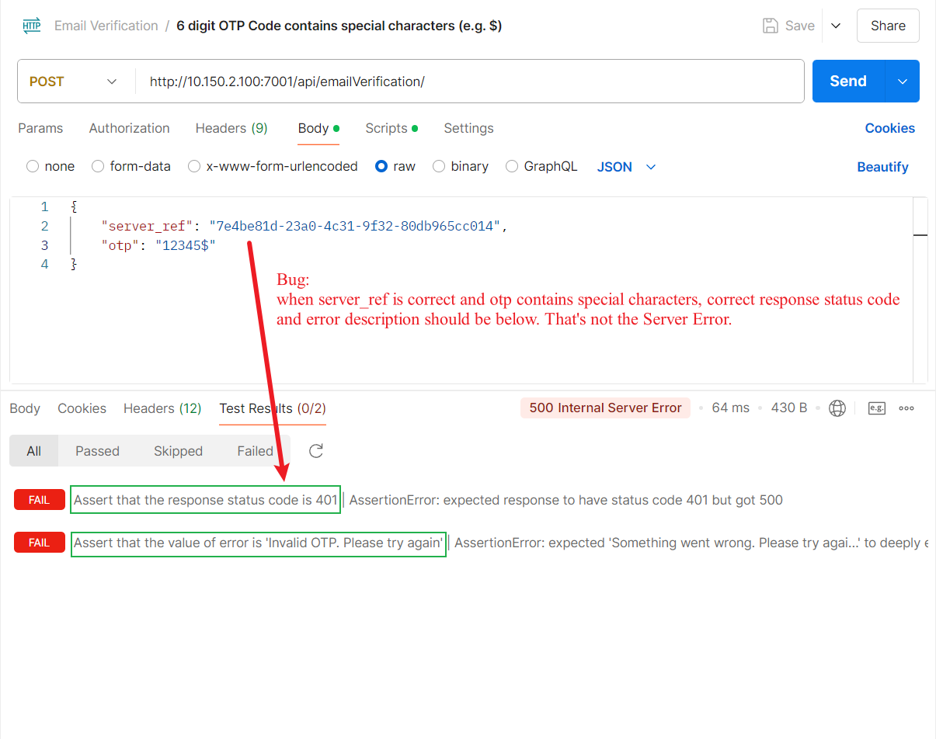

Bug 6: Test 5 numbers OTP Code
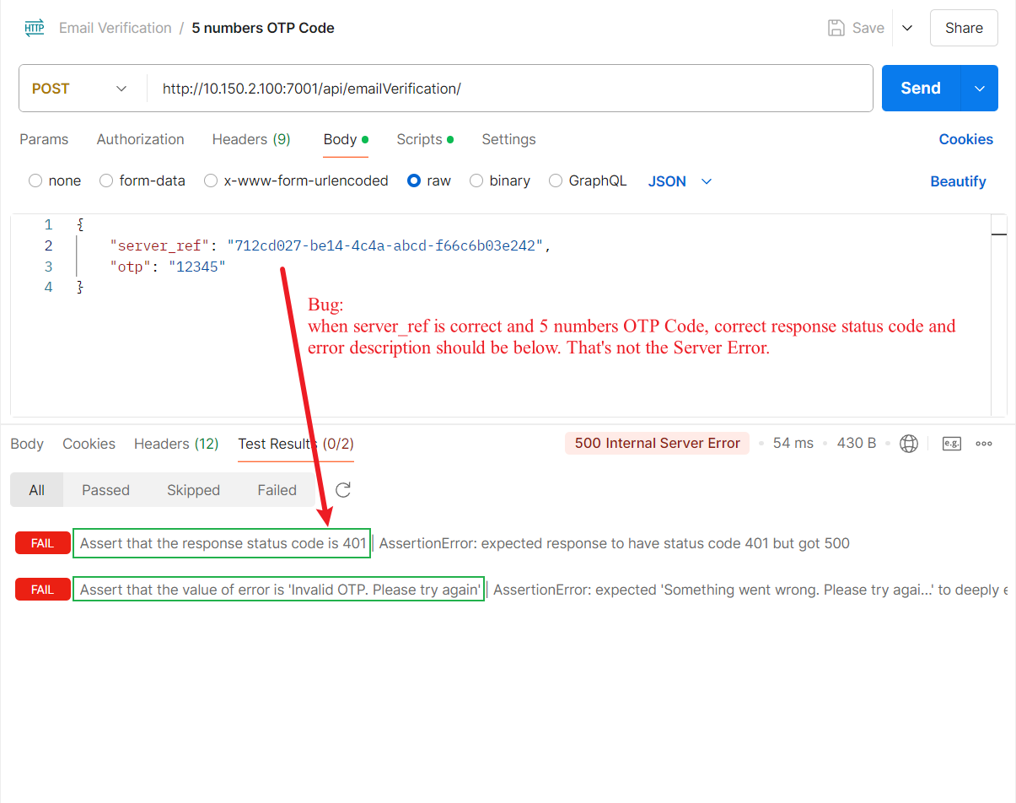

Bug 7: Test 7 numbers OTP Code
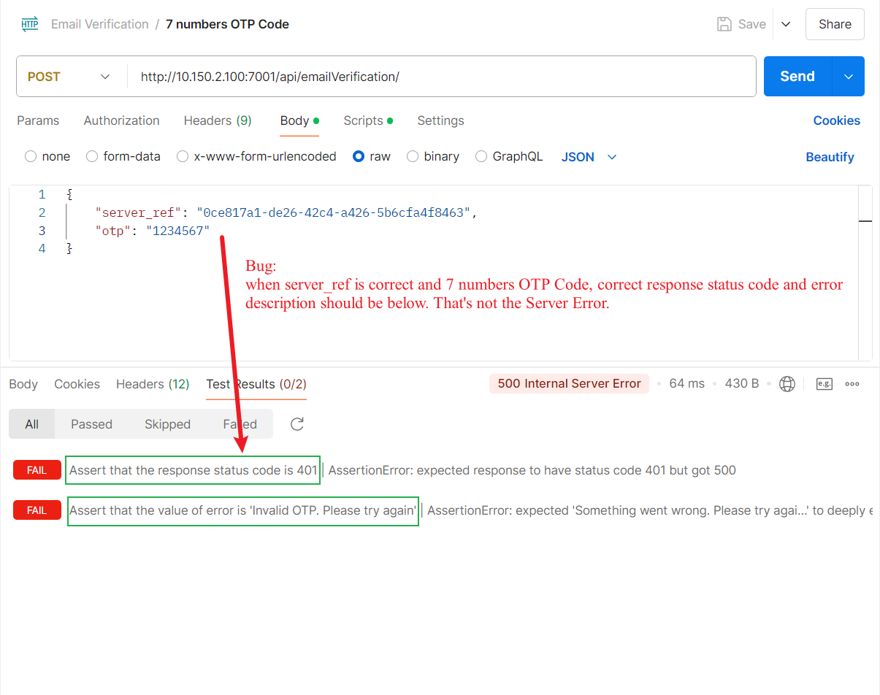

Bug 8: Test Invalid server_ref
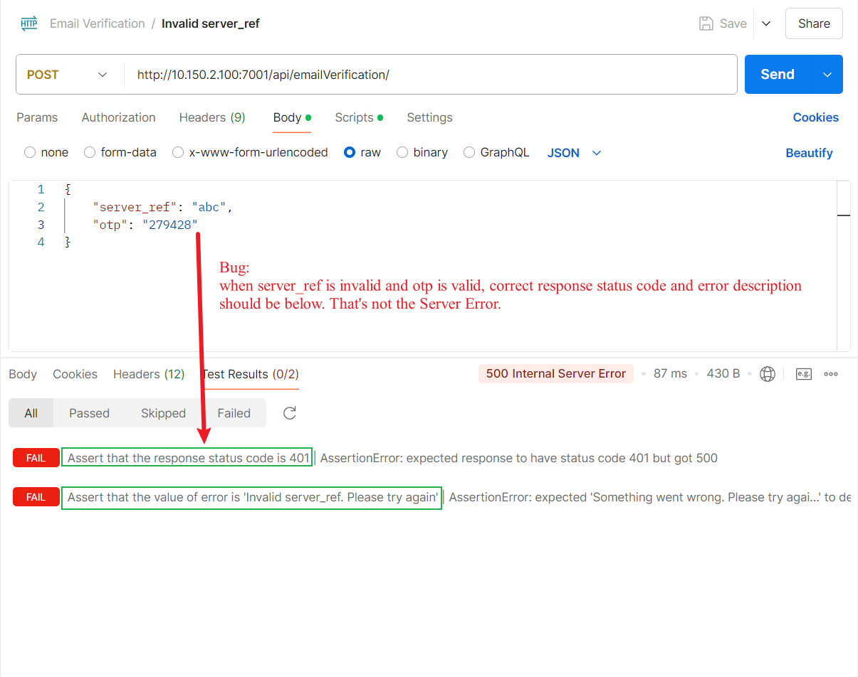

Bug 9: Test Missing Parameter
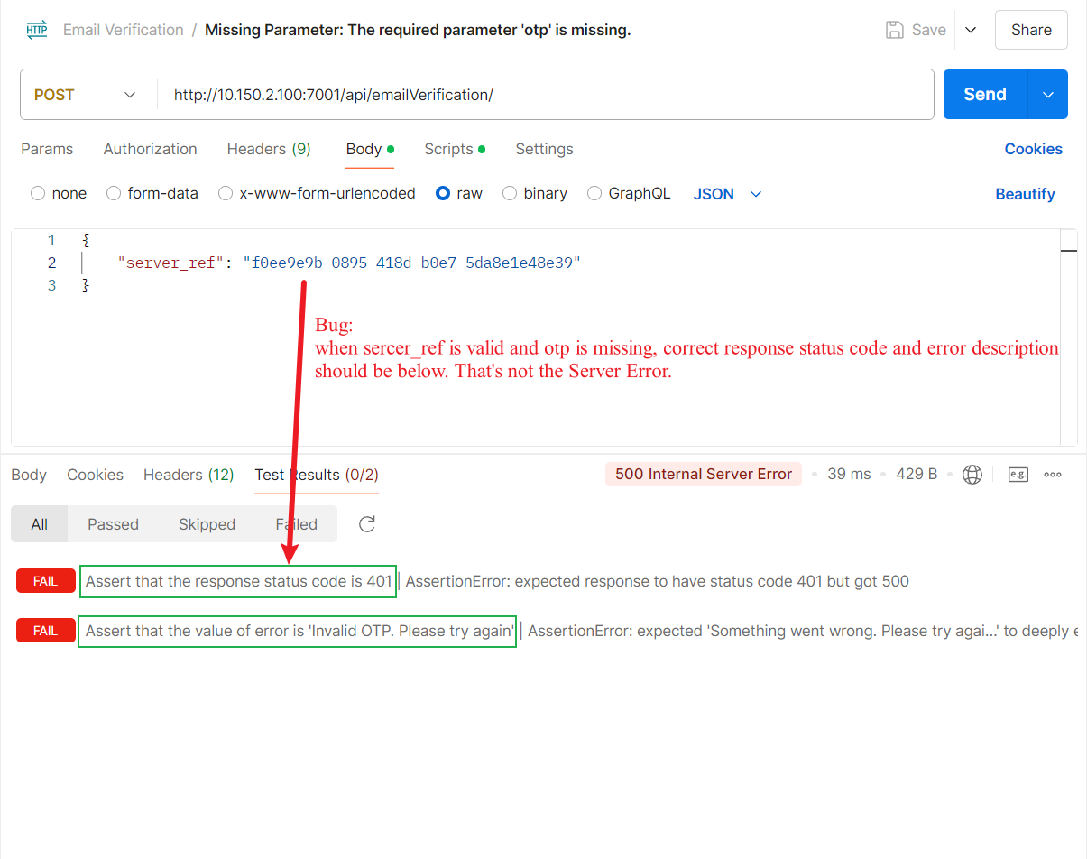

Bug 10: Test Incorrect Parameter Name
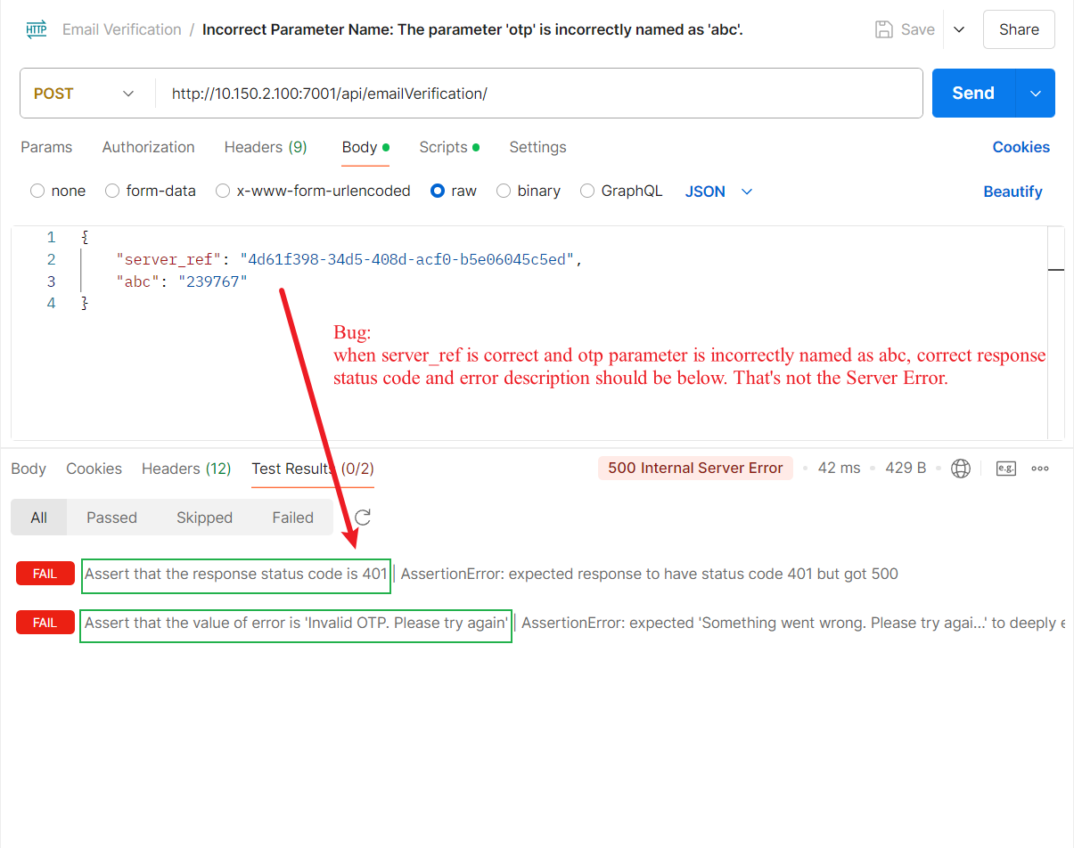

Bug 11: Test OTP is correct but it has expired
